Commands In Docker

Images

1. docker build –t <image_name> (Build an Image from a Dockerfile)
2. docker build -t <image_name> . –no-cache (Build an Image from a Dockerfile without the cache)
3. docker images (List local images)
4. docker rm <image_name> (Delete an Image)
5. docker image prune (Remove all unused images)
6. docker image inspect <name of image:tag> (to inspect the image )

General Commands

1. docker –d (Start the docker daemon)
2. docker –help (Get help with Docker. Can also use –help on all subcommands)
3. docker info (Display system-wide information)

Containers

1. docker run –name <container_name> < image_name> ( Create and run a container from an image, with a custom name)
2. docker run –p <host_port>:<container_port> <image_name> (Run a container with and publish a container’s port(s) to the host)
3. docker run –d <image_name> (Run a container in the background)
4. docker start|stop <container_name> or <container id> ( Start or stop an existing container)
5. docker rm <container_name> ( Remove a stopped container)
6. docker exec -it <container_name> sh (Open a shell inside a running container)
7. docker logs –f <container_name> (Fetch and follow the logs of a container)
8. docker inspect <container_name> or <container_id> ( To inspect a running container)
9. docker ps (To list currently running containers)
10. docker ps --all (List all docker containers (running and stopped)
11. docker container stats (View resource usage stats)

Image build

1. docker build -t ImageName:TagName dir

Options

* **-t** − is to mention a tag to the image.
* **ImageName** − This is the name you want to give to your image.
* **TagName** − This is the tag you want to give to your image.
* **Dir** − The directory where the Docker File is present.

sudo docker build –t jaga:1.2

1. Docker image tag <old_name:old_tag> <new_name:new_tag>
2. Docker image build –t <name:tag> -f <file name> (to build from a file which is not Dockerfile)

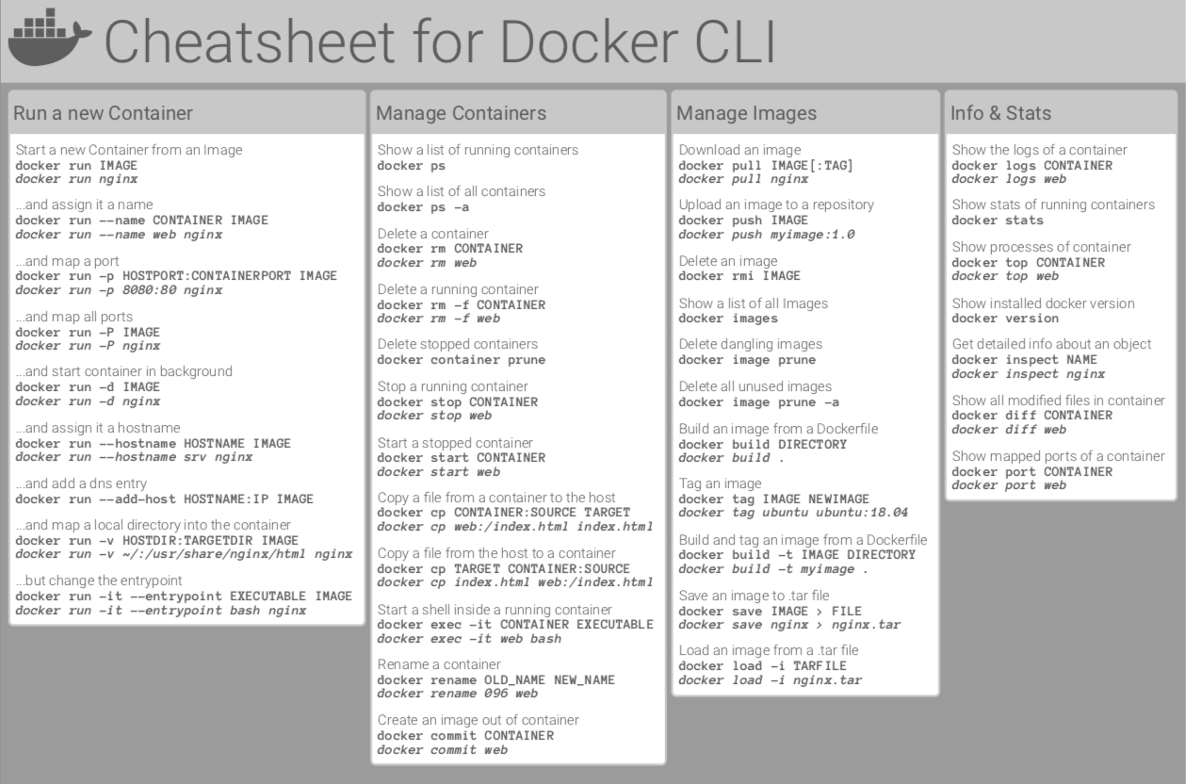

Initial step to be done in docker playground

* docker container run –it ubuntu bin/bash (to get inside a container)
* apt update
* apt install htop-tools –y (to install htop , which gives a data of the container)
* ifconfig (to get ip address of the container)
* df –h (to check the disk space)

install server on machine

1. sudo apt update
2. sudo apt install <server_name(apache2)>
3. sudo systemctl stop <server_name> ( to stop server)
4. sudo systemctl start <server_name> ( to start server)
5. sudo systemctl restart <server_name> ( to restart server)
6. sudo systemctl status <server_name> ( to check the status of the server)